**A PROJECT REPORT**

**on**

**“Implementation Of Open Access Database Of EEG Signals**

**Recorded During Imagined Speech Using AutoEncoder”**

**Submitted to**

**KIIT Deemed to be University**

**In Partial Fulfillment of the Requirement for the Award of**

**BACHELOR’S DEGREE IN COMPUTER SCIENCE AND ENGINEERING**

**BY**

**KRITICA ARORA 2105551**

**ARGHYA ROOPAM BEHARA 21051720**

**SUBHASIS SWAIN 21052201**

**UNDER THE GUIDANCE OF**

**DR. RABI SHAW**



**SCHOOL OF COMPUTER ENGINEERING**

**KALINGA INSTITUTE OF INDUSTRIAL TECHNOLOGY**

**BHUBANESWAR, ODISHA -751024**

**April 2024**

KIIT Deemed to be University

School of Computer Engineering

Bhubaneswar, ODISHA 751024



CERTIFICATE

This is certify that the project entitled

“**Implementation Of Open Access Database Of EEG Signals**

**Recorded During Imagined Speech Using AutoEncoder”**

submitted by

KRITICA ARORA 2105551

ARGHYA ROOPAM BEHARA 21051720

SUBHASIS SWAIN 21052201

is a record of bonafide work carried out by them, in the partial fulfillment of the requirement for the award of Degree of Bachelor of Engineering (Computer Sci-ence & Engineering) at KIIT Deemed to be university, Bhubaneswar. This work is done during the year 2023-2024, under our guidance.

Date: 13/04/2024

Dr. Rabi Shaw

**Project Guide**

**Acknowledgements**

We are profoundly grateful to **Dr. Rabi Shaw** of **Affiliation** for his expert guidance and continuous encouragement throughout to see that this project meets its target since its commencement to its completion. .....................

Kritica Arora

Arghya Roopam Behera

Subhasis Swain

**ABSTRACT**

With the help of an AutoEncoder-based approach, we aim to implement an open-access database of EEG signals which was recorded during imagined speech. This was also recorded with a focus on vowel articulation. The methodology involved in this project is loading the dataset, then dividing the dataset into smaller files corresponding to individual vowels. Next it was followed by preprocessing the data through normalization using the max-min technique. Along with this, in order to enhance the discriminative features, feature extraction is performed by utilizing the discrete wavelet transform.

Using an AutoEncoder, classification is then done and executed. We implemented the Siamese Network model with Triplet loss to enhance the classification accuracy. Moreover, for comparative analysis, a base model using Neural Networks is developed. This study adds to the larger body of research in voice recognition and neuroinformatics by creating this easily available database and using cutting edge methods in EEG signal processing and machine learning.

**Keywords:** AutoEncoder, EEG signals, Imagined speech, Vowel articulation, Siamese Network, Discrete wavelet transform

Contents

|  |  |  |  |  |
| --- | --- | --- | --- | --- |
| 1 | Introduction | | | 1 |
| 2 | Basic Concepts/ Literature Review | | | 2 |
|  | 2.1 | Electroencephalography (EEG) | | 2 |
|  | 2.2 | Speech Recognition | | 2 |
|  | 2.3 | Imagined Speech | | 2 |
|  | 2.4 | Vowel Articulation | | 3 |
|  | 2.5 | Auto Encoder | | 3 |
|  | 2.6 | Siamese Network | | 4 |
| 3 | Problem Statement / Requirement Specifications | | | 5 |
|  | 3.1 | Project Planning........................... | | 5 |
|  | 3.2 | Project Analysis (SRS)................. | | 5 |
|  | 3.3 | System Design ………………….. | | 6 |
|  |  | 3.3.1 | Design Constraints …… | 6 |
|  |  | 3.3.2 | System Architecture (UML) / Block Diagram … | 6 |
| 4 | Implementation | | | 7 |
|  | 4.1 | Methodology / Proposal ........................... | | 7 |
|  | 4.2 | Testing / Verification Plan ……………. | | 8 |
|  | 4.3 | Result Analysis / Screenshots …………. | | 8 |
|  | 4.4 | Quality Assurance …………………….. | | 9 |
| 5 | Standard Adopted | | | 10 |
|  | 5.1 | Design Standards . . . . . . . . . . . . . . . | | 10 |
|  | 5.2 | Coding Standards . . . . . . . . . . . . . . | | 10 |
|  | 5.3 | Testing Standards . . . . . . . . . . . . . . . | | 10 |
| 6 | Conclusion and Future Scope | | | 11 |
|  | 6.1 | Conclusion ……………………….. | | 11 |
|  | 6.2 | Future Scope ………………………. | | 12 |
| References | | | | 13 |
| Individual Contribution | | | | 13 |
| Plagiarism Report | | | | 14 |

Chapter 1

Introduction

Recent years have seen tremendous breakthroughs in speech recognition technology, opening up new applications for everything from virtual assistants to medical diagnosis. The utilization of Electroencephalography (EEG) signals presents a promising path among the different approaches to speech detection, especially when dealing with imagined speech. Imagined speech tasks have gained attention for their potential to improve communication for those with speech impairments. They entail mentally practicing speech without actually vocalizing it.

In this regard, by developing an open-access library of EEG signals captured during imagined speech and concentrating on vowel articulation, this study aims to advance EEG-based speech recognition systems. Speech recognition using EEG signals has a number of benefits, such as portability, non-intrusiveness, and even real-time processing.

The primary objectives of this project include:

Database Implementation:

Data Preprocessing:

Classification Techniques:

Base Model Development:

By doing this, the project hopes to advance the fields of voice recognition and neuroinformatics research and open the door to more advanced assistive devices and communication technology for people with speech difficulties. Furthermore, the establishment of an open-access EEG database encourages cooperation and knowledge exchange among researchers, propelling further developments in this area.

Chapter 2

Basic Concepts/ Literature Review

This section provides an overview of the fundamental concepts and related literature pertinent to the system developed in this project.

2.1 Electroencephalography (EEG):

Electrodes are usually implanted on the scalp to capture electrical activity in the brain using the EEG technique. It is frequently used to investigate brain function and identify neurological abnormalities in clinical and neuroscience contexts.

2.2 Speech Recognition:

The technique of taking spoken words and turning it into text or commands mechanically. It uses a number of methods, including pattern recognition, language modeling, and audio modeling.

2.3 Imagined Speech:

In imagined speech tasks, speech is simulated or thought through without being spoken aloud. EEG signals obtained during tasks involving imagined speech can be used for speech recognition and can offer insights into the neurological mechanisms involved in speech generation.

2.4 Vowel Articulation:

The process of producing vowel sounds in speech, known as vowel articulation, involves moving the vocal tract to create particular acoustic qualities. Distinct articulatory characteristics, unique to each vowel, can be recorded in EEG signals during speech tasks that are simulated.

2.5 AutoEncoder

One kind of artificial neural network used for unsupervised learning is called an autoencoder. It gains the ability to convert input data from a higher-dimensional form into a lower-dimensional representation and back again. It is frequently utilised for applications involving feature learning, denoising, and data compression.

2.6 Siamese Network:

A neural network architecture known as a Siamese network is made up of two identical subnetworks that share the same parameters. It is frequently applied to tasks that require measuring similarity or dissimilarity, including face recognition or, in this instance, the classification of EEG signals.

2.7 Triplet Loss:

In Siamese networks, the triplet loss loss function is used to learn embeddings that preserve distances between comparable data and push apart dissimilar samples. Triplets of samples are used to train the network: an anchor sample, a positive sample that resembles the anchor, and a negative sample that differs from the anchor.

2.8 Neural Networks:

Computational models known as neural networks are modeled after the architecture and functionality of biological brain networks. They are made up of layers of networked nodes, or neurons, and they may use training algorithms like backpropagation to extract complicated patterns from data.

2.9 Summary

In summary, this section provides a comprehensive overview of the basic concepts, tools, and techniques relevant to the system developed in this project. By understanding these concepts, readers can gain insights into the underlying principles and methodologies employed in the project, thereby facilitating a better understanding of the subsequent sections.

Chapter 3

Problem Statement / Requirement Specifications

3.1 Project Planning

During the project design phase, the procedures for putting the open-access database of EEG signals captured during fictitious speech into practice are outlined. This includes establishing project goals, scheduling tasks, distributing resources, and detecting possible dangers. To maintain efficient project management, factors like team composition and communication routes will also be taken into account.

3.2 Project Analysis

The needs for the EEG database implementation will be carefully examined during the project analysis phase. This entails being aware of the requirements of all parties involved, including practitioners and researchers in the domains of neuroinformatics and speech recognition. Documentation of the requirements will include information on preprocessing, feature extraction, data loading, and classification methods. The database's design and development will be based on this analysis.

3.3 System Design

3.3.1 Design Constraints

In order to effectively direct the development process, design limitations will be defined. Budgetary restrictions, needs for interoperability with current systems, and limitations in processing resources are a few examples of restraints. Potential roadblocks can be avoided and the effective implementation of the EEG database can be ensured by recognising and addressing these limits early in the project.

3.3.2 System Architecture / Block Diagram

The EEG database system's components and interactions will be depicted through the system architecture. A block diagram or UML diagram illustrating the data flow from dataset loading to classification utilizing AutoEncoder-based algorithms will be included in this. The design will guarantee that all parts function as a whole to accomplish the project's goals while preserving scalability and flexibility for further features down the road.

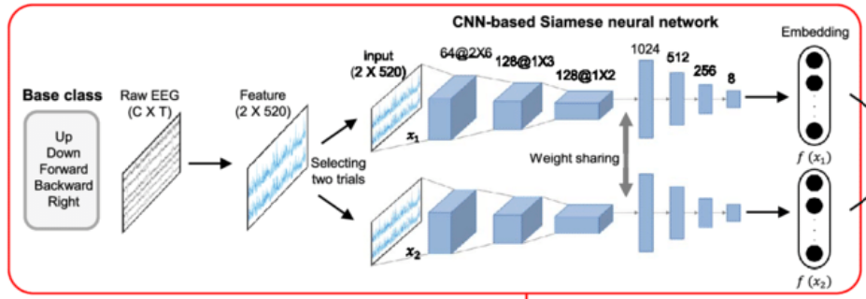

Chapter 4

Implementation

4.1 Methodology / Proposal

This section will go over the approach and suggested implementation of the public database of EEG signals captured during fictitious speech.

Loading of the Dataset: We will explain how to obtain and enter the EEG dataset into the system. This could entail gathering data via experimental recordings or gaining access to datasets that are made publically available.

Dividing the dataset and creating smaller files: We divided the dataset into smaller files that corresponded to particular vowels in order to assist processing in an efficient manner. This fine-grained separation allowed for targeted study of individual speech elements.

Preprocessing of Data: We normalize the data using the max-min approach to improve its consistency and comparability between samples. In order to standardize the dataset and reduce any potential biases during further analysis, this step was essential.

Feature extraction using discrete wavelet transform: We were able to extract discriminative features from the EEG signals by utilizing the discrete wavelet transform. We were able to extract complex patterns from the data using this technique, which improved the data's representational strength for classification tasks.

Performing classification using AutoEncoder: We carried out the classification using AutoEncoder-based methods, specifically the Siamese Network model with Triplet loss. We were able to attain higher classification accuracy by utilizing the Siamese Network's intrinsic structure and Triplet loss's discriminative ability.

Creating a base model using Neural Networks: Furthermore, we used neural networks to create a baseline model for comparison. We used this model as a reference to assess how well our sophisticated classification methods performed.

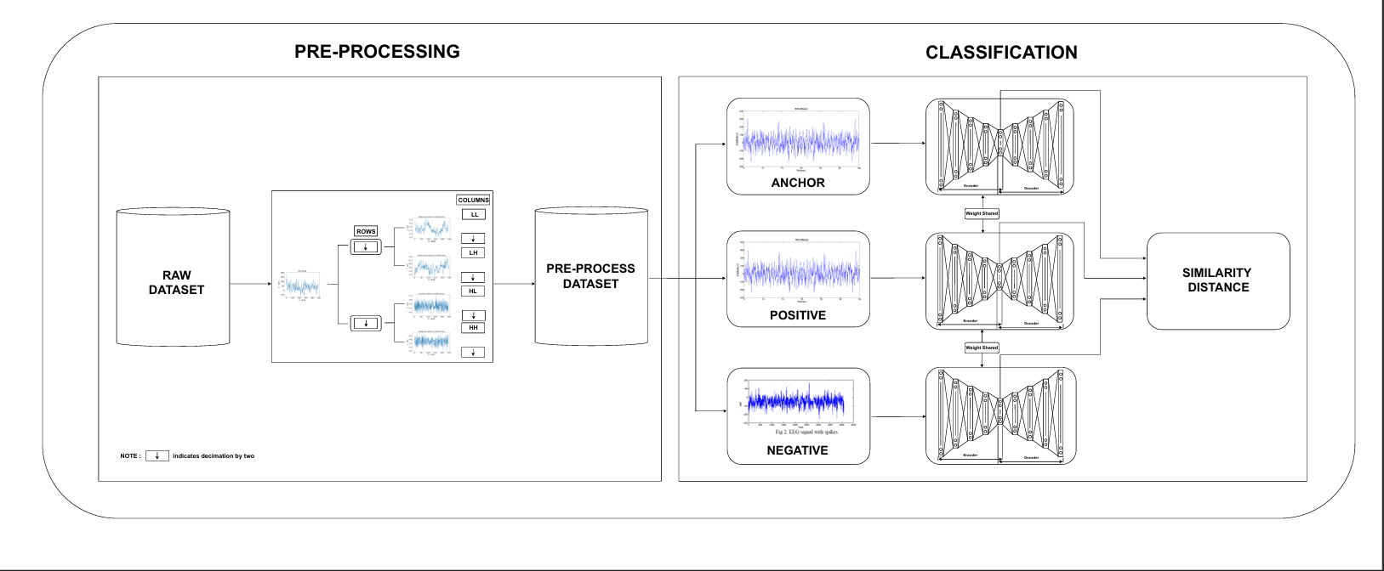

Fig 1: Model Used

4.2 Testing / Verification Plan

A thorough testing and verification plan was created to guarantee the dependability and correctness of our implementation:

|  |  |  |  |  |
| --- | --- | --- | --- | --- |
| Test ID | Test Case Title | Test Condition | System Behavior | Expected Result |
| T01 | Model Training Test | Training dataset is provided | Model is trained using selected algorithm | Trained model with optimized parameters is generated |
| T01 | Model Evaluation Test | Testing dataset is provided | Model predicts vowels | Prediction accuracy metrics are computed |

4.3 Result Analysis / Screenshots

The outcomes of our implementation were carefully examined and analyzed:

Classification results:We carefully examined the classification outcomes obtained using the AutoEncoder-based method as well as the basic Neural Network model. This analysis shed light on the effectiveness and functionality of our classification methods.

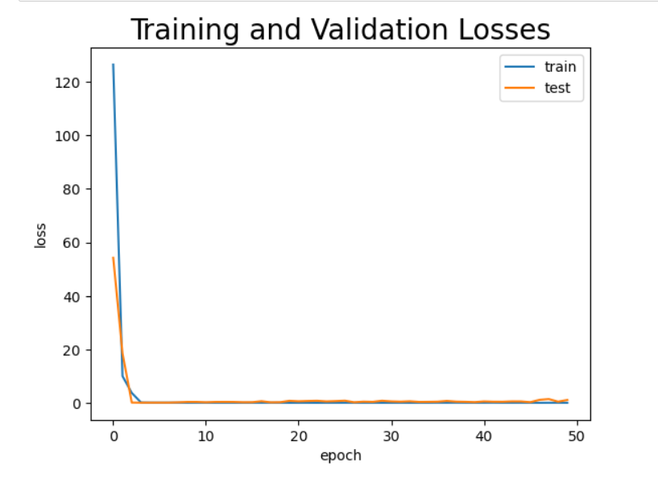

Fig 2: Training Loss vs Validation Loss

4.4 Quality Assurance

Strict quality assurance procedures were put in place to maintain the caliber and dependability of our system:

Code review: To find and fix any inconsistencies or implementation mistakes, a thorough code review procedure was carried out.

Validation and verification: To make sure that our system complies with the requirements as stated and meets the expected performance levels, we carefully validated and confirmed it.

Documentation: To offer thorough documentation of the system architecture, implementation specifics, and usage guidelines, significant documentation efforts were made. For future maintenance and reference, this documentation is a great resource.

Chapter 5

Standards Adopted

5.1 Design Standards

In order to guarantee the coherence and expandability of our system architecture, we strictly followed recognised design guidelines for our project. Our project's organization and structure were determined by the design criteria, which guaranteed consistency and clarity in its execution.

Our experiment was organized in accordance with standard protocols for biomedical signal storage, as outlined in the materials supplied. Each subject's data was arranged into separate folders in our database, which included audio and EEG signal files as well as pertinent paperwork. This method improved the scalability and usability of the database by making it easier to add additional data sets without the need for reorganization.

5.2 Coding Standards

We adhered to industry-standard coding rules to preserve code quality and foster consistency throughout our codebase. These norms covered things like required documentation, indentation styles, and name conventions. We wanted to reduce errors, improve teamwork, and make the code easier to comprehend by following coding standards.

5.3 Testing Standards

We implemented stringent testing guidelines to guarantee the stability and dependability of our implementation. These guidelines covered creating thorough test cases, applying test-driven development (TDD) techniques, and making use of automated testing frameworks. We verified system operation, found flaws, and guaranteed the integrity of our software product using methodical testing processes.

Chapter 6

Conclusion and Future Scope

6.1 Conclusion

To sum up, this effort effectively created an open-access database of EEG signals captured while imagining speech, with a particular emphasis on vowel articulation. We obtained encouraging results in classification accuracy by combining sophisticated techniques such as discrete wavelet transform for feature extraction and AutoEncoder-based classification with a Siamese Network model. This database's establishment closes a significant gap in the supply of EEG datasets that are available to the public for use in imagined speech recognition research.

This project's exploratory experiment showed that EEG signals include important information about words that are envisioned. The classifier, Random Forest, produced acceptable accuracy levels, suggesting that there is room for more progress in the deciphering of imagined speech. These results highlight how important it is to carry out more research in this area in order to fully realize the promise of EEG-based brain-computer interfaces (BCIs) for thought decoding and enhancing communication for people with speech problems.

6.2 Future Scope

There are numerous directions this topic could go in terms of study and development going forward:

Investigation of Extra Features: More investigation is required to find EEG signal features that offer improved discriminative information for imagined speech recognition. The accuracy of the categorization may be improved by experimenting with temporal features like the mean and standard deviation of each channel.

Classifier Optimisation: More research and development into classification algorithms can result in a higher degree of accuracy when it comes to the decoding of imaginary words. Examining the effectiveness of different classifiers and group techniques may provide insightful information.

Improvement of Dataset: The open-access EEG database can be made richer and more conducive to in-depth studies on imagined speech recognition by adding more recordings and a wider variety of stimuli.

Integration with BCI Systems: There is a lot of potential to improve communication and engagement for people with speech impairments by integrating the existing methodologies and discoveries into practical applications like brain-computer interfaces.

We can enhance the field of imagined voice recognition and help create novel solutions for enhancing communication technologies and human-computer interaction by exploring these directions for future research and development.

References

# [[1]](https://medium.com/deep-learning-hk/compute-document-similarity-using-autoencoder-with-triplet-loss-eb7eb132eb38) Compute Document Similarity Using Autoencoder With Triplet Loss

# [[2]](https://medium.com/@rinkinag24/a-comprehensive-guide-to-siamese-neural-networks-3358658c0513) A Comprehensive Guide to Siamese Neural Network

[[3]](https://github.com/Ekeany/Siamese-Network-with-Triplet-Loss/blob/master/MachinePart1.ipynb) Sample Code referred of Siamese-Network

[[4]](https://www.tensorflow.org/tutorials/generative/autoencoder" \l ":~:text=An%20autoencoder%20is%20a%20special,representation%20back%20to%20an%20image.) Intro to Auto-Encoders

[[5]](https://www.v7labs.com/blog/autoencoders-guide) Auto-Encoders in Deep Learning

[[6]](https://towardsdatascience.com/applied-deep-learning-part-3-autoencoders-1c083af4d798) Auto-Encoders and its Implementation

[[7]](https://pyimagesearch.com/2023/03/06/triplet-loss-with-keras-and-tensorflow/) Triplet Loss with Keras and TensorFlow

[[8]](https://www.analyticsvidhya.com/blog/2023/08/introduction-and-implementation-of-siamese-networks/) Understanding Siamese Network

[[9]](https://pyimagesearch.com/2020/11/30/siamese-networks-with-keras-tensorflow-and-deep-learning/) Siamese Network with Keras and TensorFlow and Deep Learning

[[10]](https://www.spiedigitallibrary.org/conference-proceedings-of-spie/10160/1016002/Open-access-database-of-EEG-signals-recorded-during-imagined-speech/10.1117/12.2255697.short" \l "_=_) Research Paper on Open Access Database of EEG signals

